# Linters Used

# 



Stylint config file from: https://gist.github.com/mydea/8a5c49b2a13320871ab29eb88a0e7d37

# Cross Browser Testing

Tested with: Sauce Labs

Resolution: 1440 x 900

* No noted issues with **modern browsers:** Safari 17, Edge 125, Chrome 125 and Firefox 126.

Edge 125



Safari 17

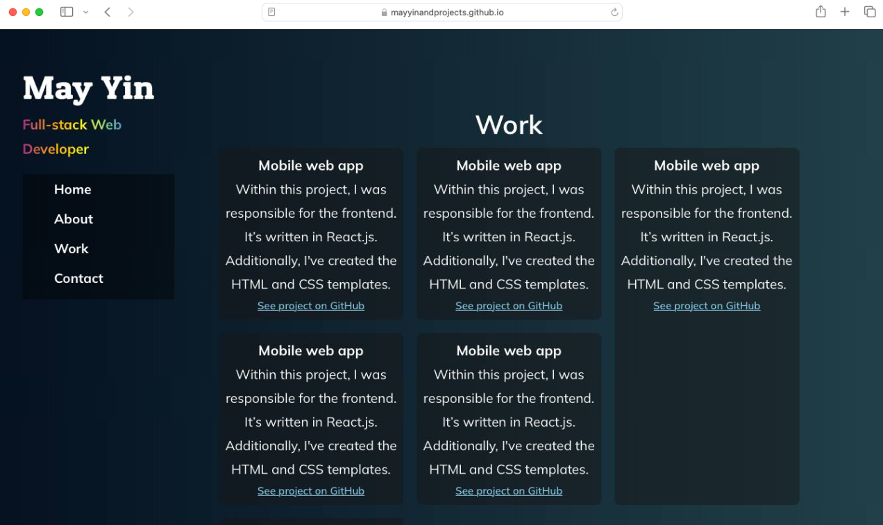

Chrome 125

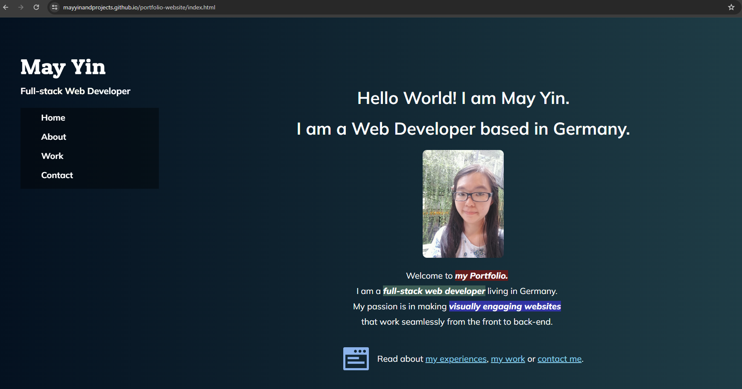

Firefox 126

